**Forget Password:**

* Enter Wrong email Shows message box. That have no message. Title and logo is wrong, it should be warning and logo should be warning logo.

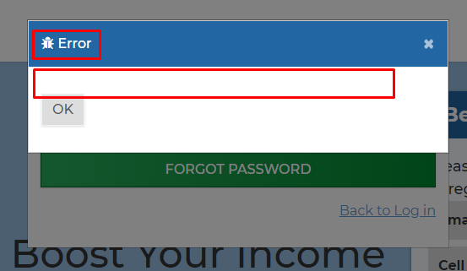

* If I have enter the correct email then received an email with reset password link, After Opening the reset link I’ve enter the wrong values it shows message box that shows no message

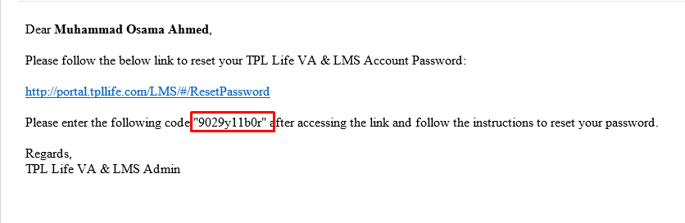

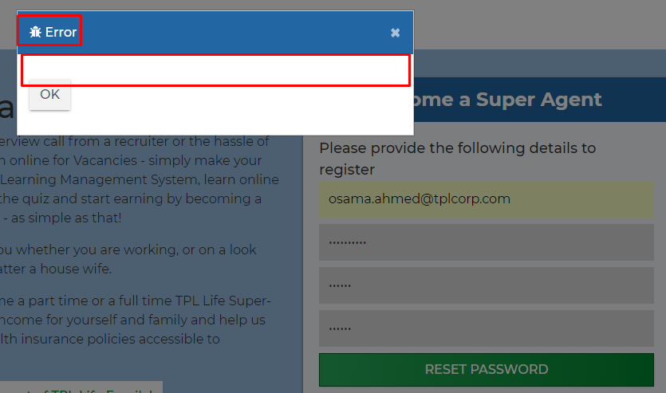

**Signup:**

Fill the signgup form and received Email/ SMS , Enter wrong values in the form and received below message that is wrong. Please show appropriate message logo and title.

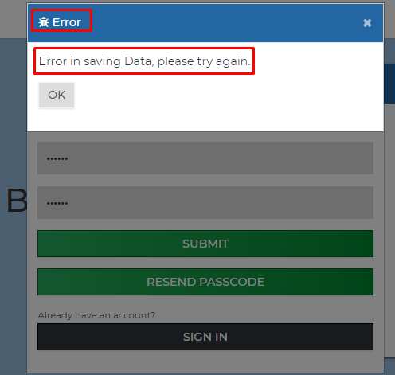

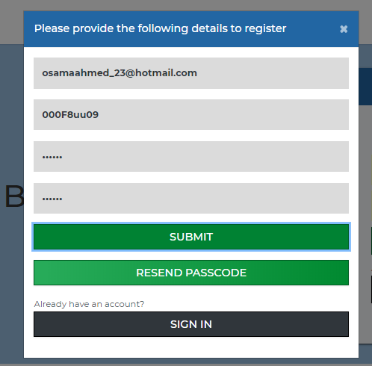

**Dashboard:**

On Clicking to the highlighted Picture Application got crashed.

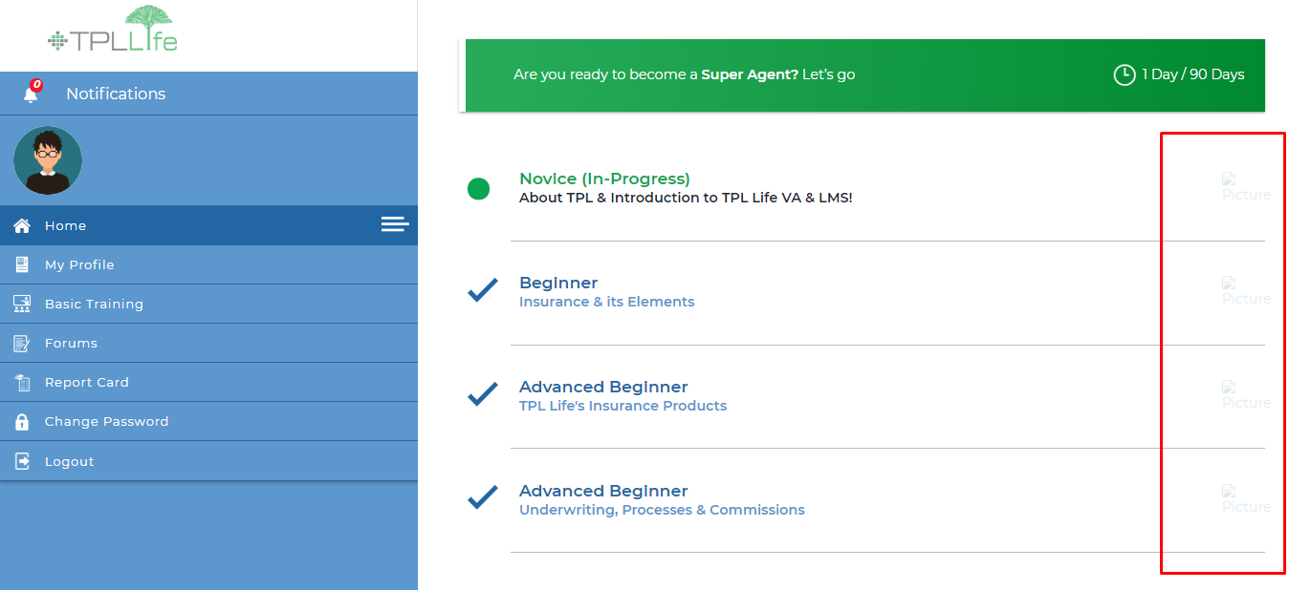

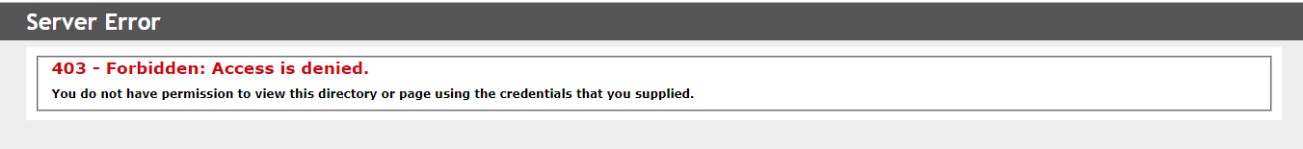

**Trainer Dashboard not showing anything.**

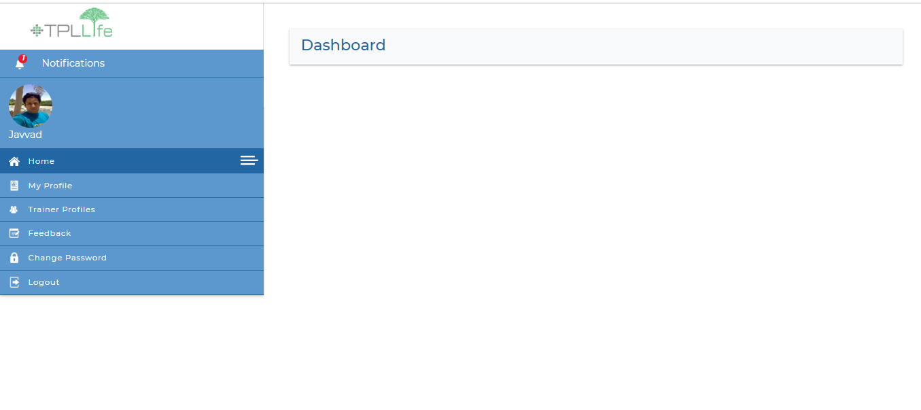

**Menu Item / Side Bar:**

There is inconsistency in the side bar as shown in the below SC.

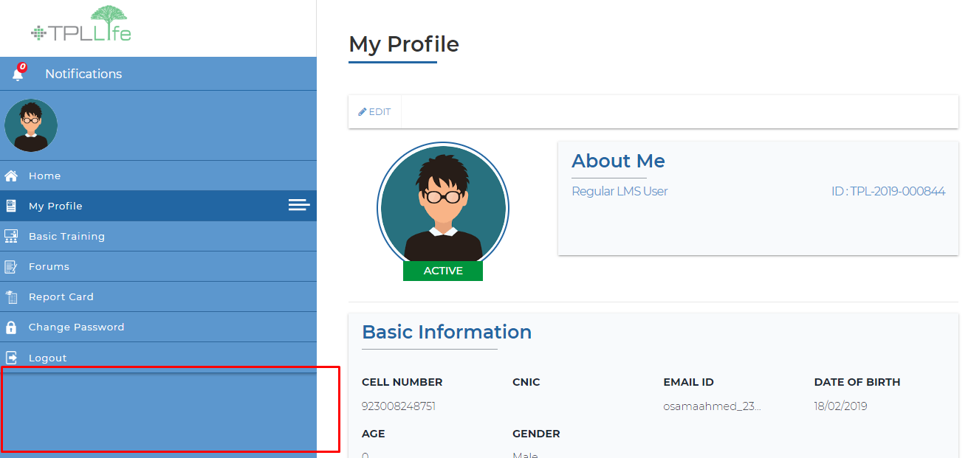

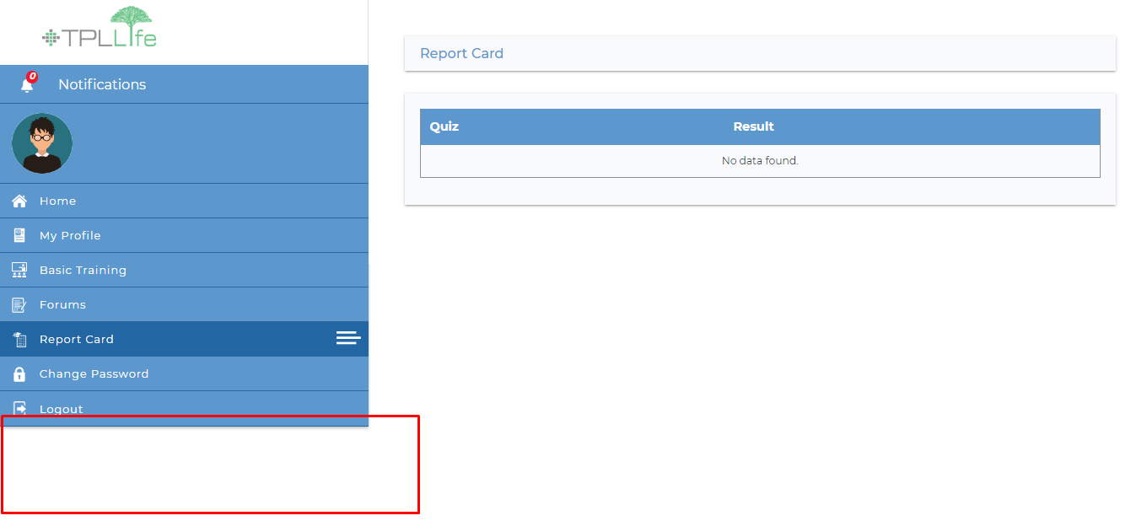

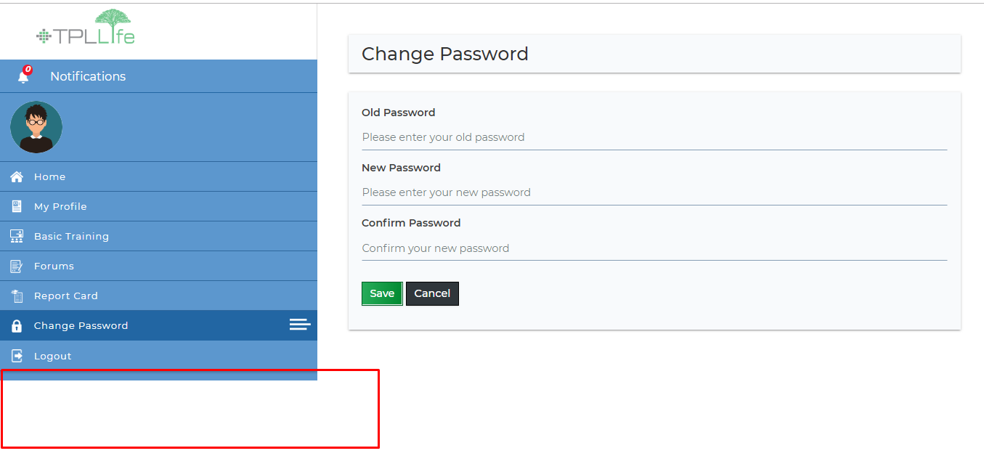

**My Profile - User Profile Edit:**

This is no Error if this is the warning if I did not fill the complete form. Shows the appropriate message.

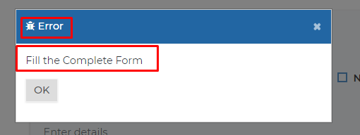

**On Edit Rights are not showing.**

**Deactivation, Blacklist and send notification are not working.**

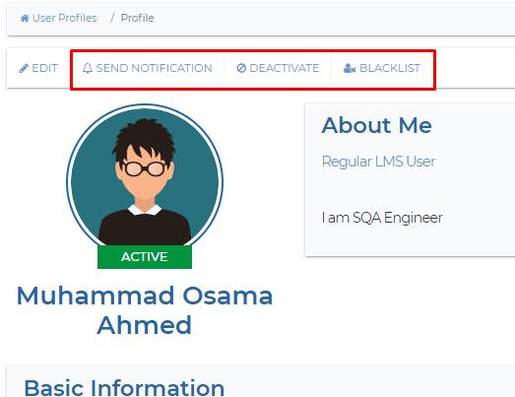

**There is no validation working on country dropdown, Although validation messages are inappropriate. Date Of Birth save current date By default cannot intimate or validate on saving.**

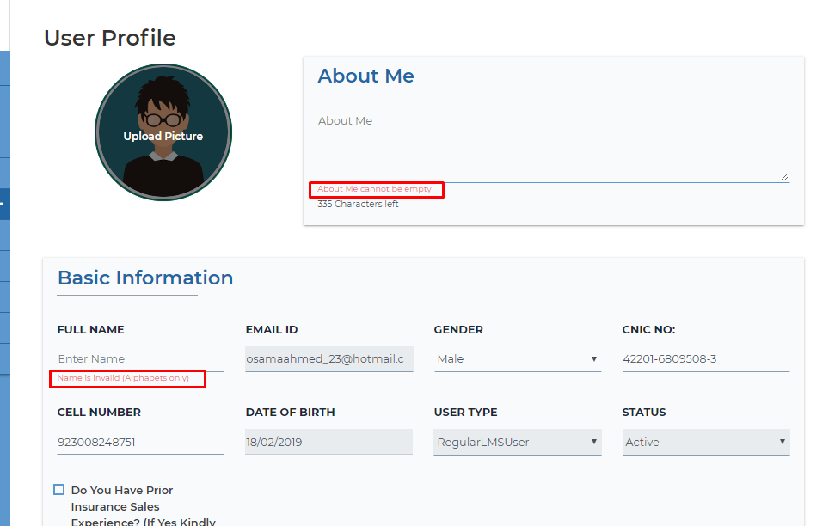

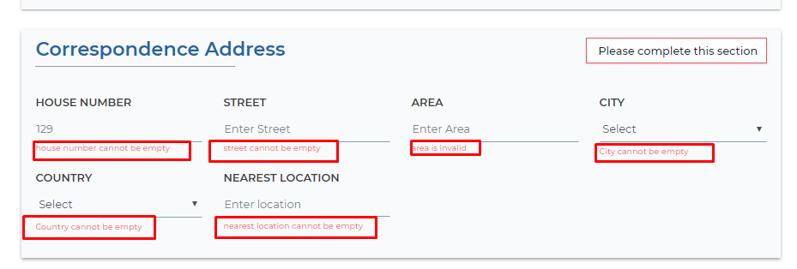

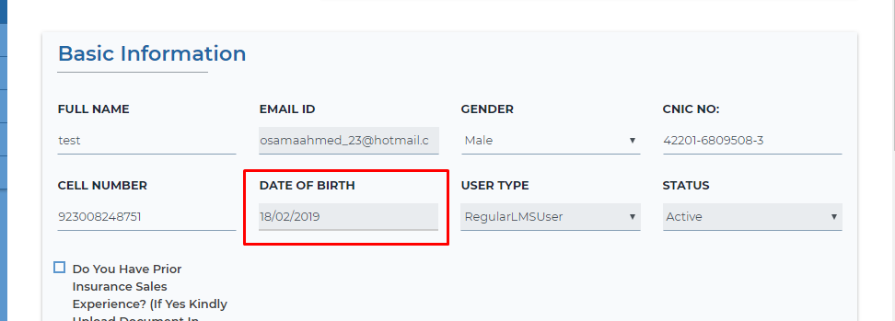

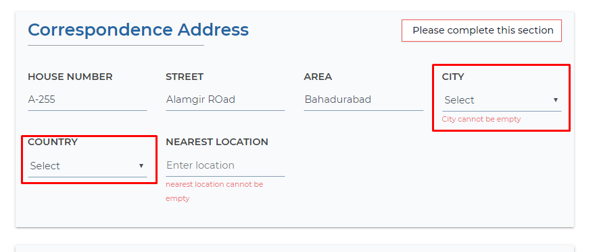

**Clicking on Add More for Educational document. IT shows nothing because of cache issue. and it is not validate on saving. DONE**

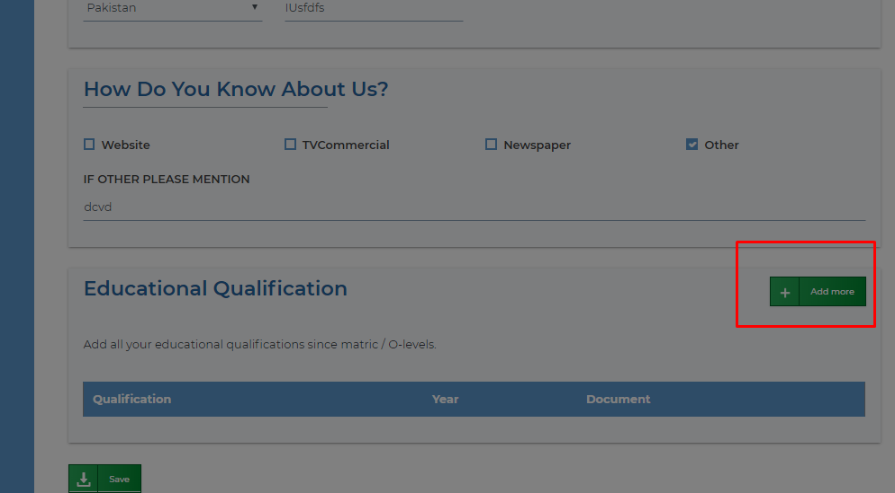

**Educational Qualification Button is not working and on clicking of document, Application got crashed.**

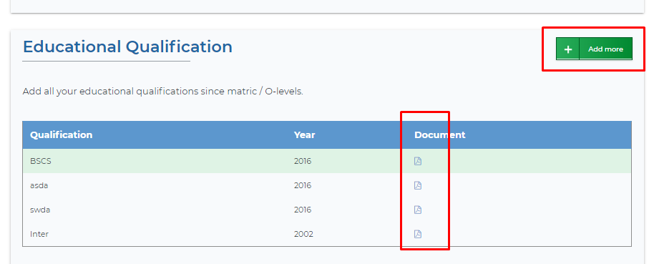

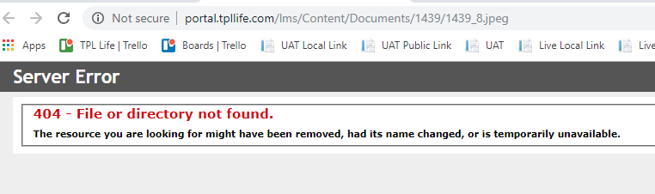

**Basic Training:**

Videos are not playing and downloading. **DONE**

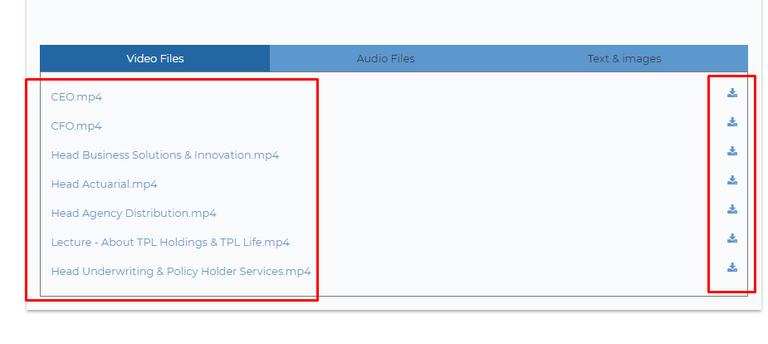

Images are not showing or downloading.

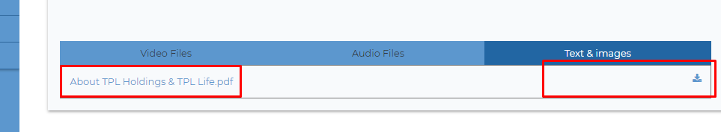

**Take Quiz**

On clicking the label take quiz I got this message, it is not error and logo is not appropriate. (I was not redirect to quiz page because of educational document is not saved yet but on saving the profile validation is not working for this education document section)

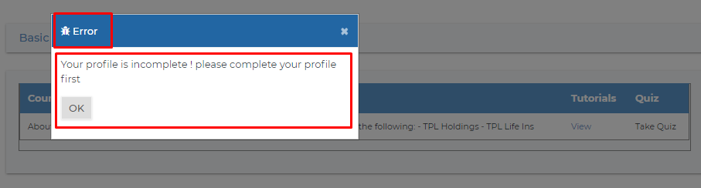

**Quiz Options selection issue.**

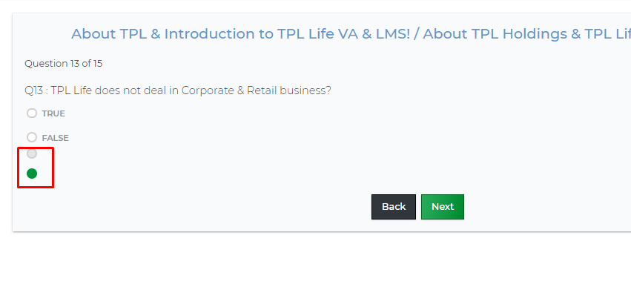

**Report Card:**

**Image is not showing.**

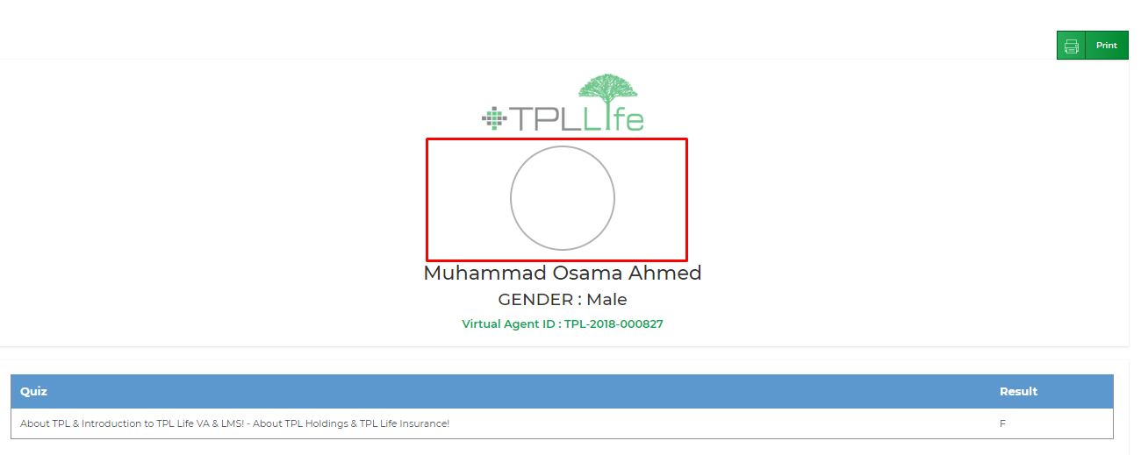

**Forum:**

**Validation Messages,**

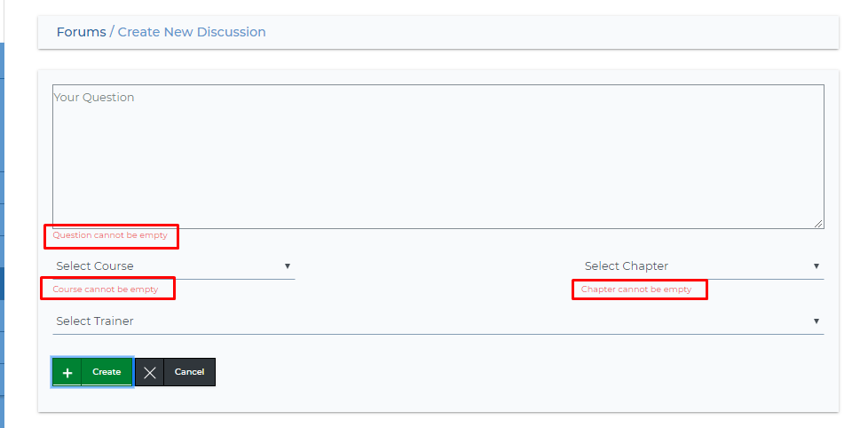

**Not showing saved discussion.**

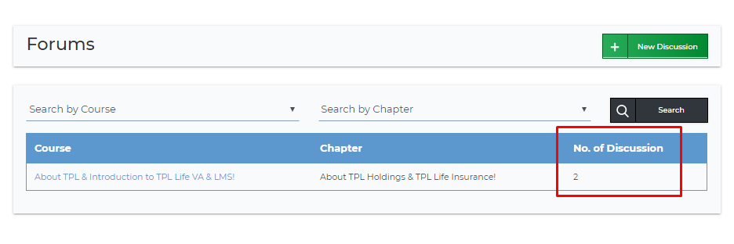

**Logout: (Cache Issue)**

* On Clicking Logout, Page refresh itself and land it on the same page. Logout not working.

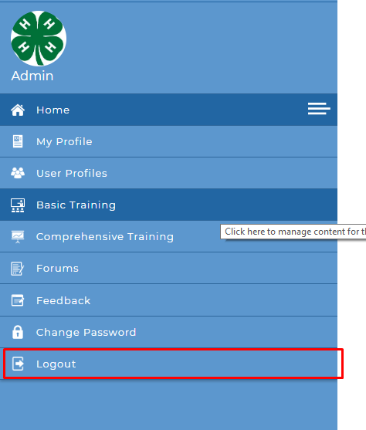

**Cache Issues over application issues.**